**Object Oriented Programming**

**Lab report: 8**



|  |  |
| --- | --- |
| Name | Ali Salman |
| Reg no | FA22-BCE-005 |
| Class | BCE- 4 |
| Instructor’s Name | Prof. Tayyab Rasul |

***Lab 10 – Polymorphism***

**Lab Tasks**

**5.1)**  **Program:**

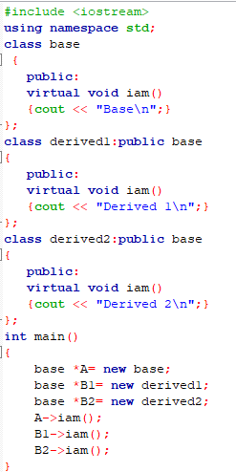

**Output:**

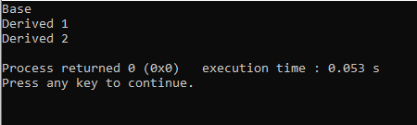

d. Remove the virtual keyword from the base class member function, run your code again, and compare the results.

**Program:**

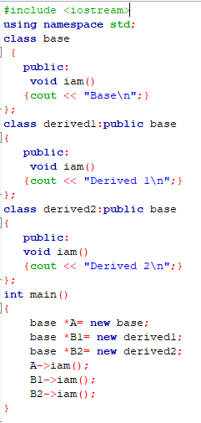

**Output:**

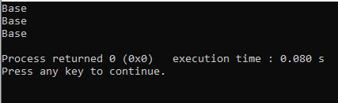

**5.2) Program:**

**Classes:**

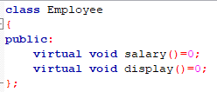

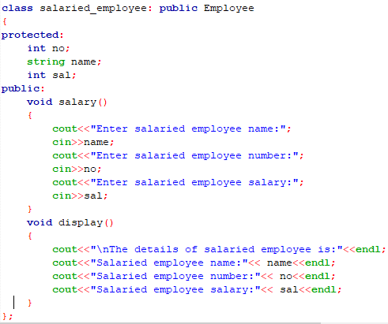

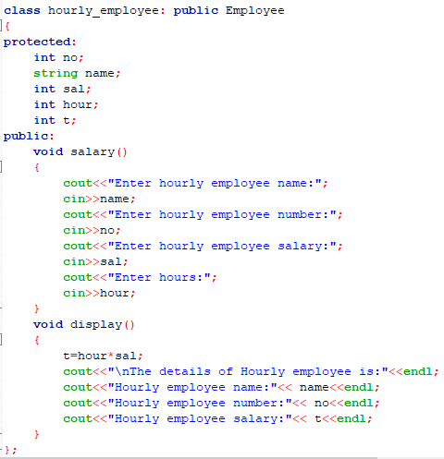

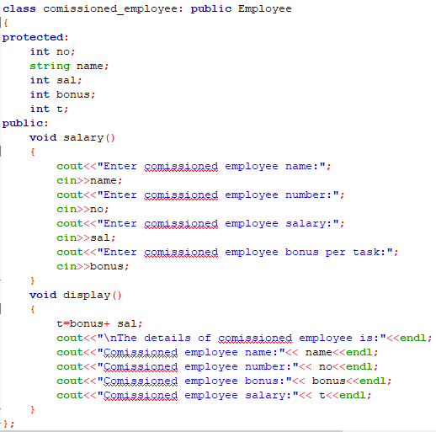

**Main:**

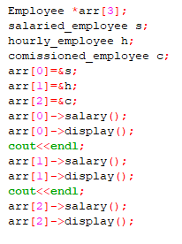

**Output:**

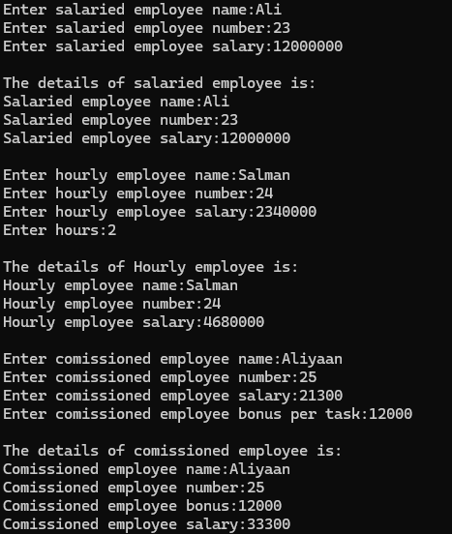

**5.3****) Program:**

**Classes:**

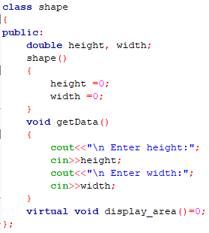

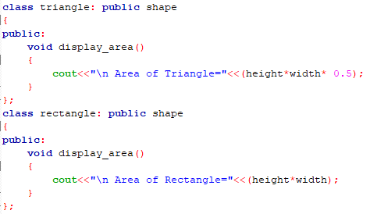

**Main:**

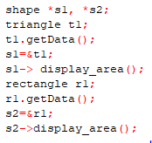

**Output:**

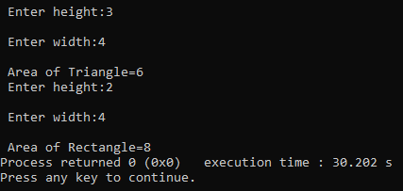

**Home Task:**

**Program:**

**Classes:**

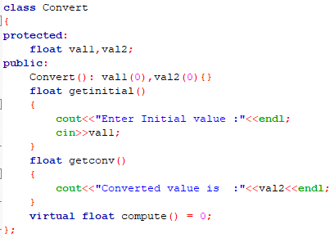

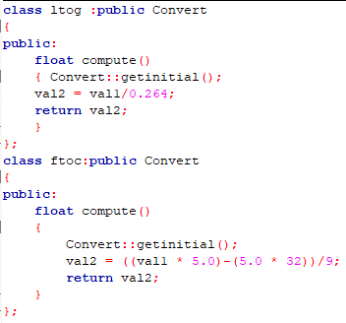

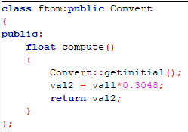

**Main:**

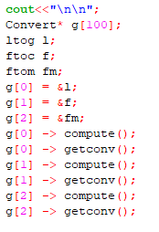

**Output:**

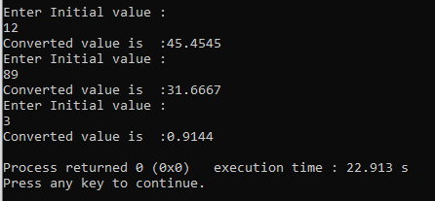

**Critical analysis:**

In this lab; we learn the concept of polymorphism that uses to perform different tasks by using inheritance feature in classes. We use virtual function to use the same function of that particular class in which it is defined. If the virtual function is not written in each class, the function of the base class is printed each time when the function is called. An abstract class is made which contains pure virtual function which is derived in that particular class and defined in inherited classes